**MD-NMD-Network Operations Intranet page updates**

<http://intranet.sydneytrains.nsw.gov.au/directorates/maintenance/network-maintenance/network-operations>

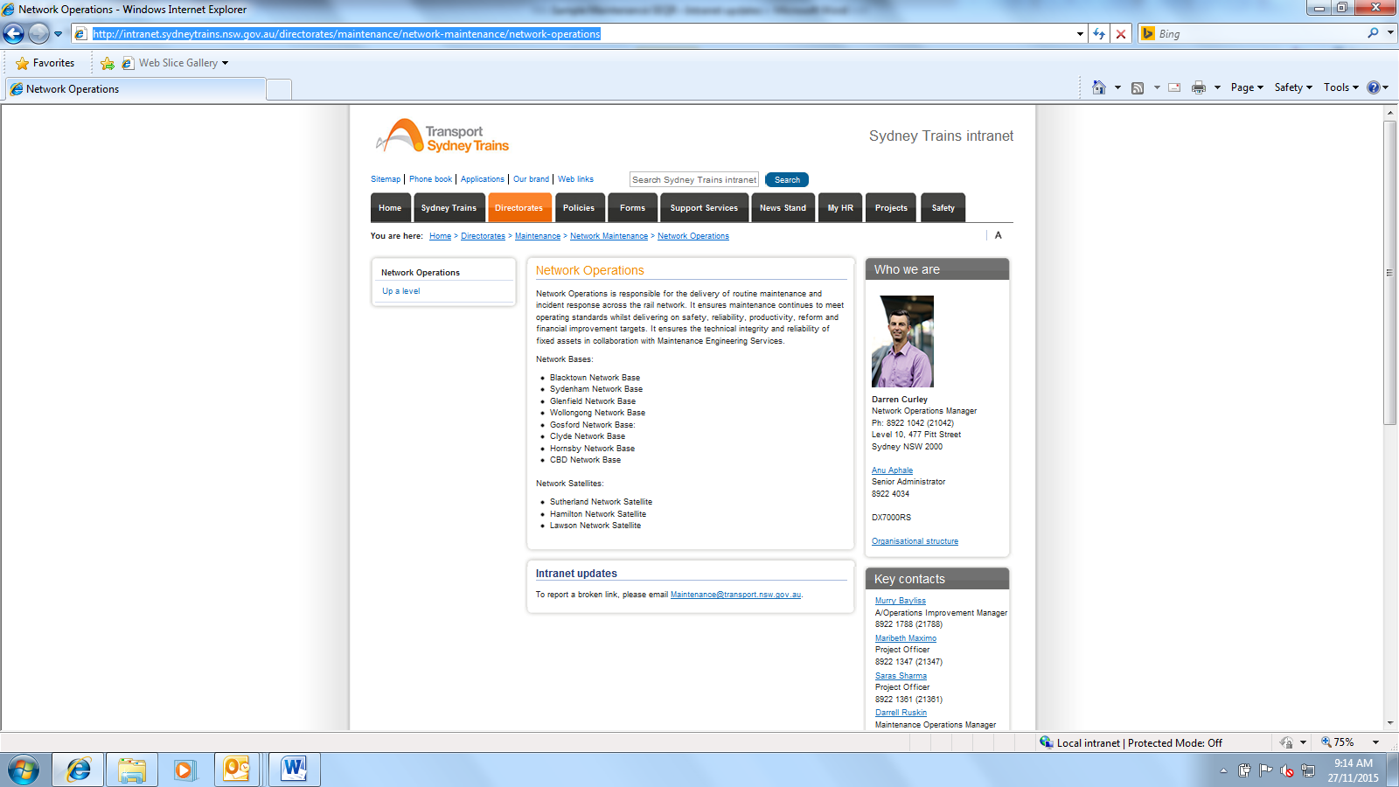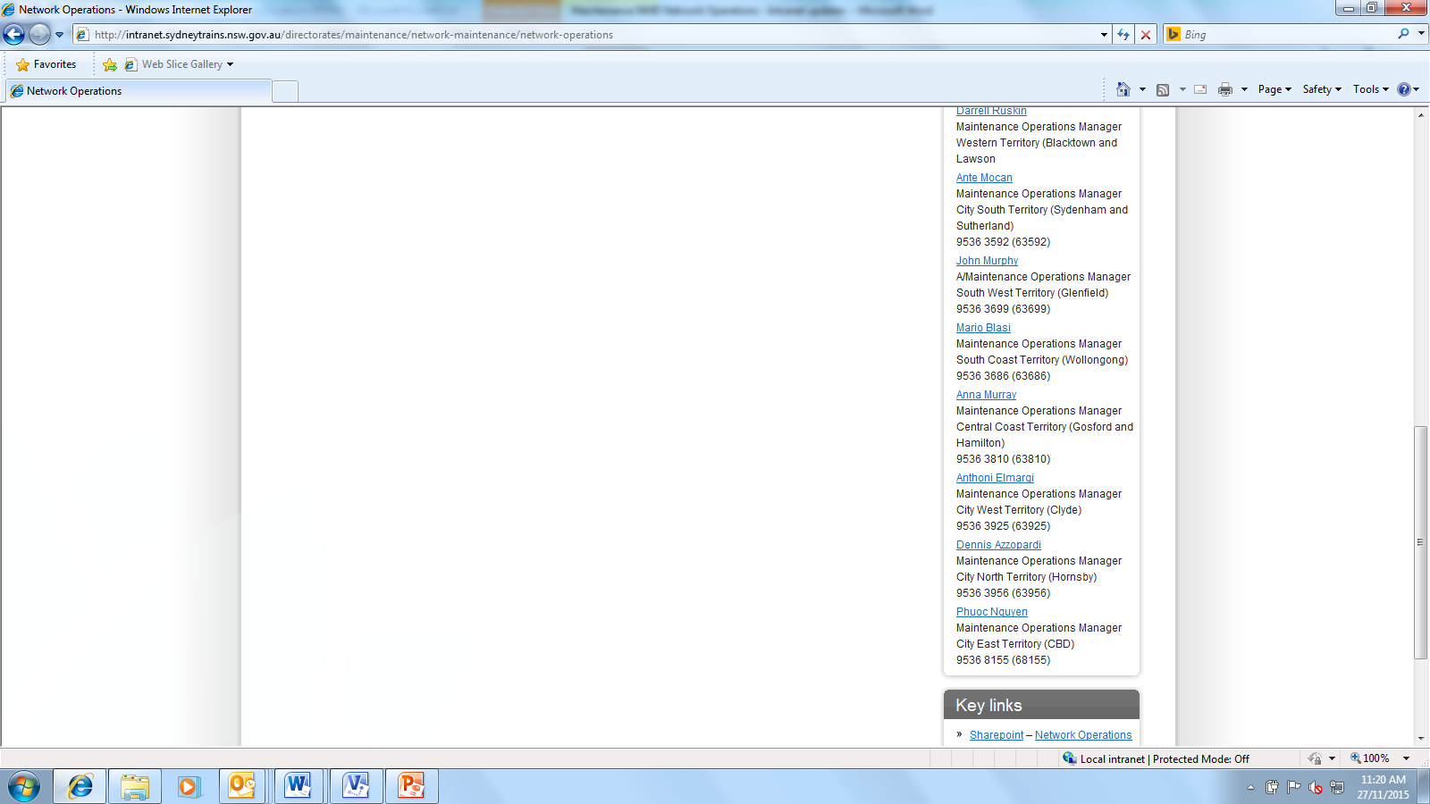

NMD launches Challenge Cup

Replace with text (1a).

Update org structure link (2a).

Replace with text (1b). Headings: “Territories” and “Operations”.

Create Information section (1d). Heading is “Information”

Delete key contacts (3a)

Move up “Key Links” section after “ Who we are section” (4a)

Apply changes (4b)

**Changes**

**SECTION 1: Network Operations**

**(1a)**

**Network Operations**

**(done)**

Network Operations is responsible for the delivery of routine maintenance and incident response across the rail network. It ensures maintenance continues to meet operating standards whilst delivering on safety, reliability, productivity, reform and financial improvement targets. It ensures the technical integrity and reliability of fixed assets in collaboration with Maintenance Engineering Services. Each territory is managed by a Maintenance Operations Manager (MOM).

**(1b)(done)**

**Territories (new heading)**

* Western Territory

Blacktown Network Base

Lawson Satellite Base

**MOM: Darrell Ruskin**

* City South Territory

Sydenham Network Base

Sutherland Satellite Base

**MOM: Ante Mocan**

* South West Territory

Glenfield Network Base

**MOM: Anthony Cricchiola**

* South Coast Territory

Wollongong Network Base

**MOM: Mario Blasi**

* Central Coast Territory

Gosford Network Base

Hamilton Satellite Base

**MOM: Anna Murray**

* City West Territory

Clyde Network Base

**MOM: Anthoni Elmargi**

* City North Territory

Hornsby Network Base

**MOM: Dennis Azzopardi**

* City East Territory

CBD Network Base

**MOM: Phuoc Nguyen**

**Operations (new heading)**

* Operations Improvement

**Manager: Murry Bayliss**

**(1c)**

**Information**

Create new Information section like this: <http://intranet.sydneytrains.nsw.gov.au/directorates/maintenance>.

Title heading **Information** (not Divisions).

Sections under should be as follows:

Resources section like this

1c.1

Use this icon:



Sub headings:

Corporate Safety

Link: <http://intranet.sydneytrains.nsw.gov.au/safety>

Local Safety Initiatives

Link: <http://sps.railcorp.nsw.gov.au/sites/mtnd/nmds/NMNWR/Safety/Forms/AllItems.aspx>

**1c.2**

Use this icon:



Sub headings:

Territory Map

Link: <http://intranet.sydneytrains.nsw.gov.au/__data/assets/pdf_file/0003/107463/Territory-Map.pdf>

Boundary Map

Link: <http://intranet.sydneytrains.nsw.gov.__data/assets/pdf_file/0019/105733/NMD-Boundary-Maps.pdf>

**1c.3**

Use this icon:



Sub headings:

List

Link: Create folder in Net Ops Sharepoint

F/N: Operations Improvement Project List (document attached)

**1c.4**

Use this icon:



Sub headings:

Course Guide

Link: \\fssydes01\contracts\General Manager\Network Maintenance Operations Group\2.Human Resource\Training

Awards

Link: <http://sps.railcorp.nsw.gov.au/sites/mtnd/nmds/NMNWR/Awards/Forms/AllItems.aspx>

EAP

Link: <http://intranet.sydneytrains.nsw.gov.au/my-hr/health/employee-assistance-and-incident-support/employee-assistance-program>

**1c.5**

Use this icon:



Link:

[http://sps.railcorp.nsw.gov.au/sites/mtnd/nmds/NMNWR/Lists/Team%20Discussion/AllItems.aspx](http://sps.railcorp.nsw.gov.au/sites/mtnd/nmds/NMNWR/Lists/Team%2520Discussion/AllItems.aspx)

**+++**

**SECTION 2: Who we are**

**(2a)(done)**

Update organisation structure link.

F/N: Network Operations Org Chart Level 4-5 Updated 281115. (Document attached)

**+++**

**SECTION 3: Key contacts**

**(3a)(done)**

Delete “Key contacts” box

**+++**

**SECTION 4: Key links**

**(4a)(done)**

Move up “Key links” box after “Who we are” section

**(4b)(done)**

Update key links sections as follow:

1. **Sharepoint – Network Operations: retain, already linked**
2. **Organisation Structure: delete**
3. **Network Base and Satellite Addresses: add**

**Link: Create link**

**F/N: Network Base Addresses (document attached)**

1. **Contact List: retain, already linked**
2. **SOI Library: retain, already linked**
3. **Network Operations Operating Manual – retain, already linked**
4. **Network Base Competition: delete**